# **Task H**

## **Hypothetical Chart**

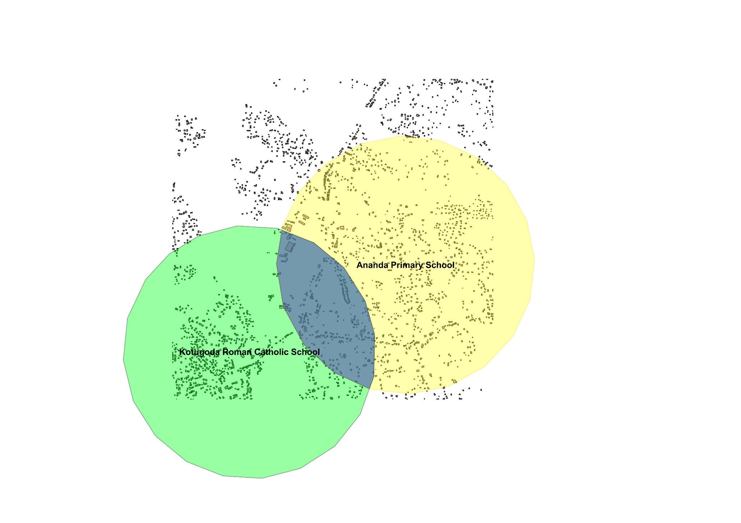

Figure 29

## **Comprehensive Chart**

**Selecting a suitable Area for Strategic Economic Research Center**

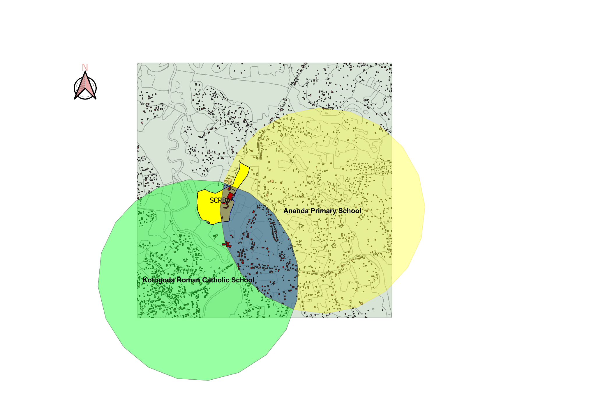

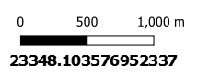 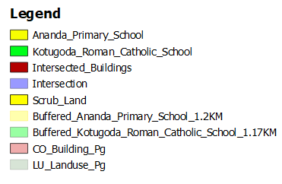

Figure 30

* Quantitative Appraisal of Erected Installations in the Authorized Segment.

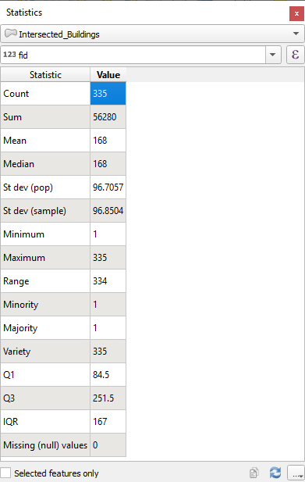

Figure 31

* Spatial Extent Aggregated by Prior Installations.

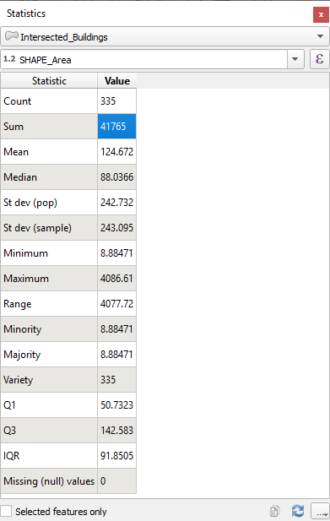

Figure 32

* Surplus Superficial Measurement of Prime Site for the Architectural Venture of the High-Caliber Economic Analysis Division.

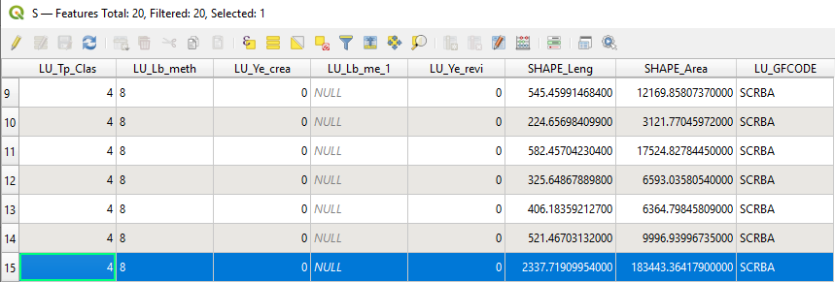

Figure 33

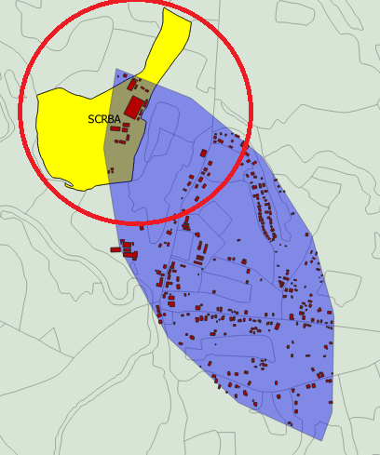

Figure 34

**Strategic Importance:**

* Given Sri Lanka's present economic shortcomings, it would be strategically desirable to establish a high-caliber analytical division.
* The division's stated goal is to improve financial capacity and knowledge of economic fundamentals by advancing growth plans and attracting indigenous companies.

**Site Selection Challenges:**

* Adding more difficulty to the search is the requirement that the location be situated between 1.17 and 1.2 kilometers from two educational institutions.
* Although other sites were identified after a thorough examination of land-use data, they were ultimately determined to be unsuitable for the project.

**Chosen Site – Scrub-Land:**

* **Benefits: The confluence area's advantageous soil qualities and the scrub-land's location allow it to fulfil the required criterion.**
* **The new analytical division will be able to meet all of their operational needs on an area of 183,443 m².**

# **APPENDIX SEGMENT**

## **Task H**

* I began by selecting the building topological vector.

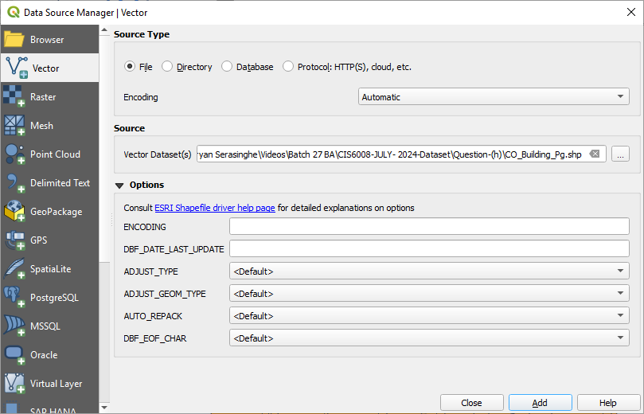

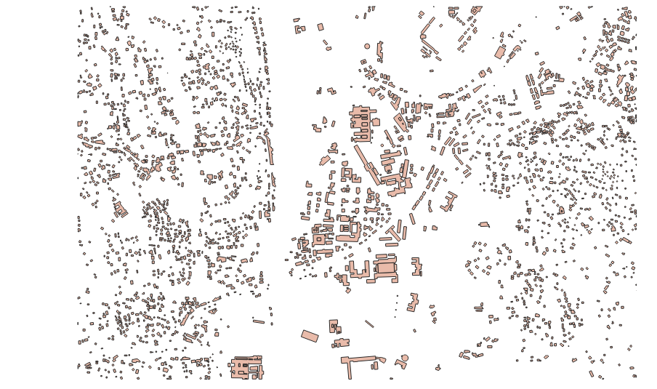

* I then identified discovered and merged pedagogical institute from building topological vector.

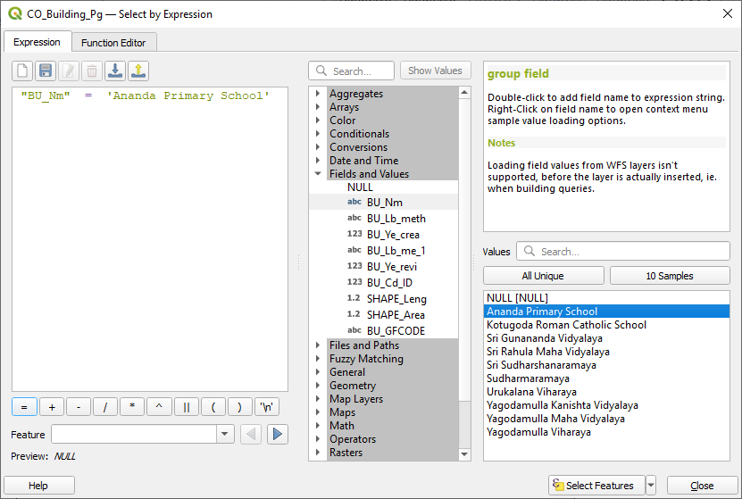

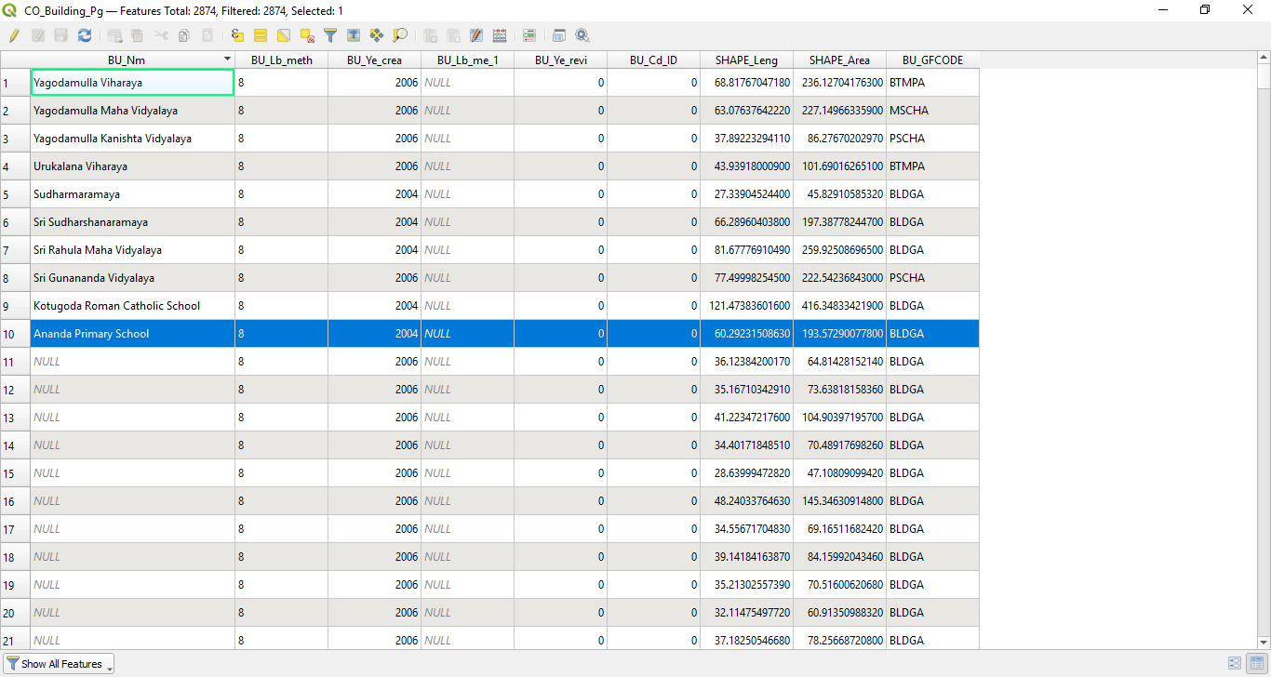

* I proceeded to discover and merge the second pedagogical institute from the building topological vector.

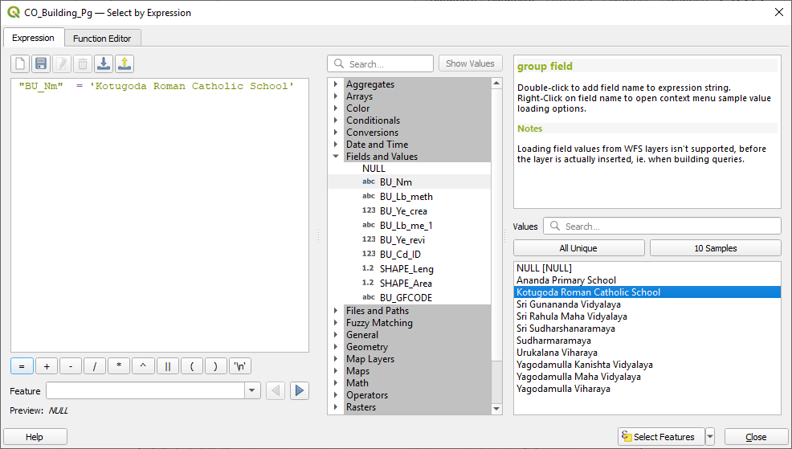

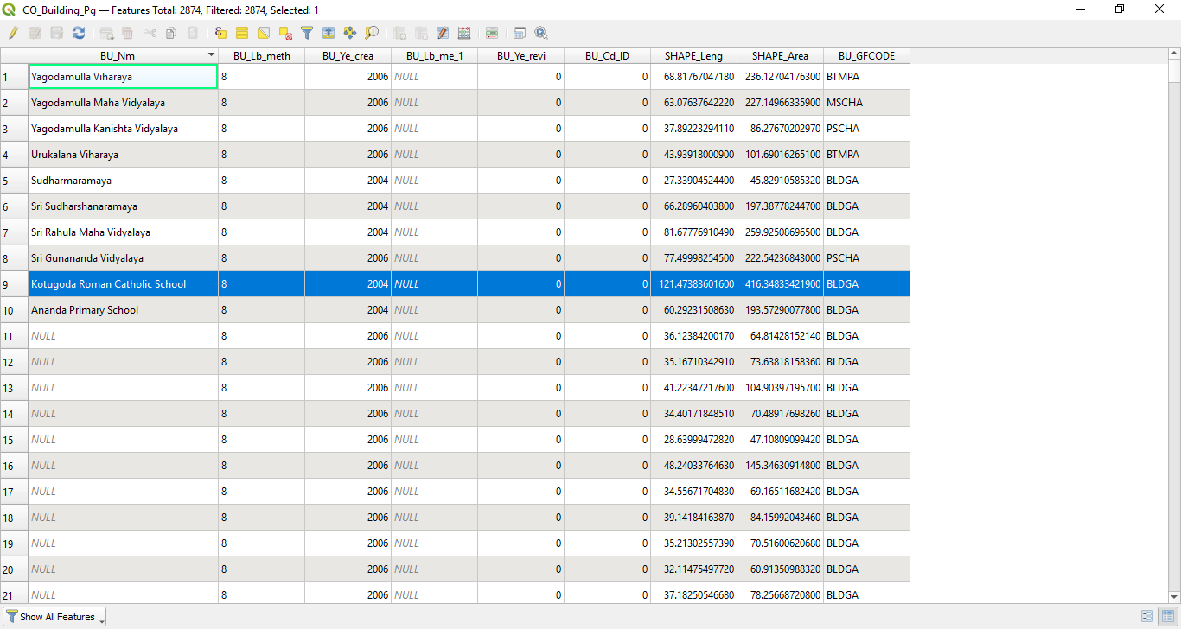

* Both pedagogical institutes are now represented.

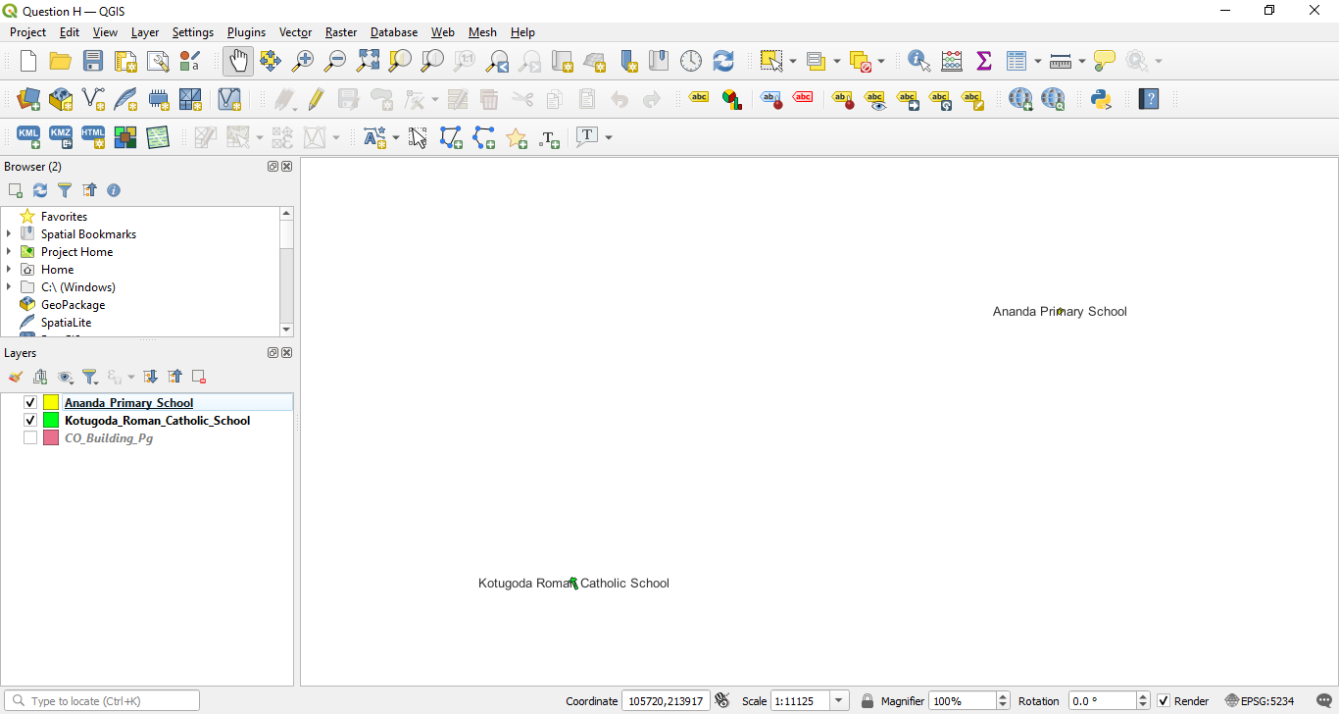

* I formed a 1.17-kilometer buffer to the first pedagogical institute.

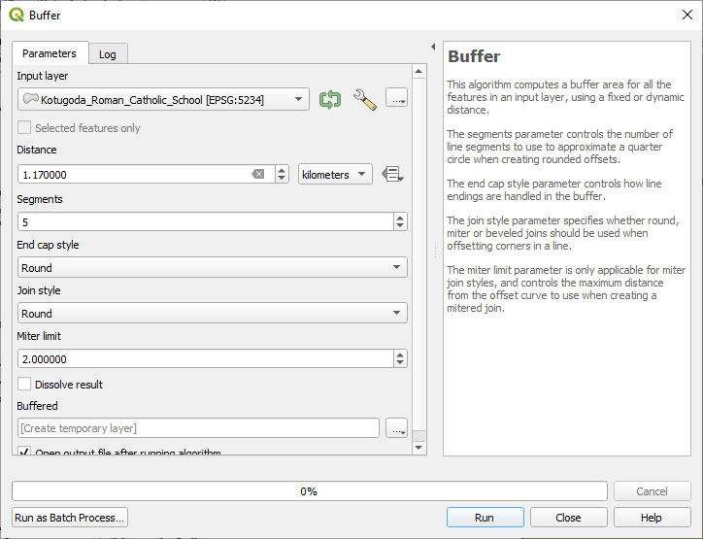

* Then, I formed a 1.17-kilometer buffer to the first pedagogical institute.

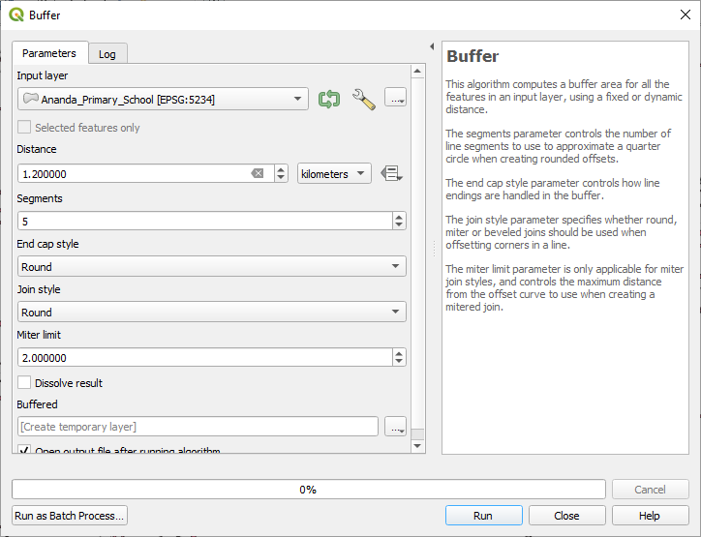

* Next, I created the confluence area.

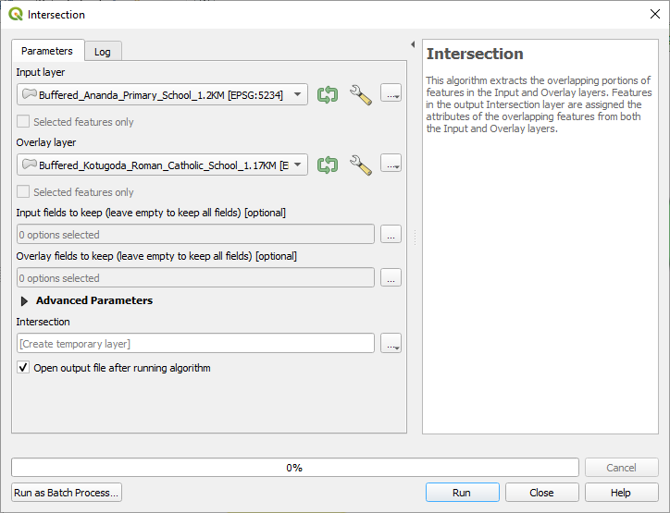

* Confluence area is shown hereunder.

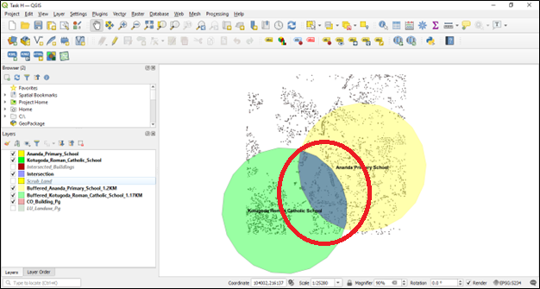

* Afterwards, I used the "select by location" algorithm to identify any and all installations throughout the confluence area.

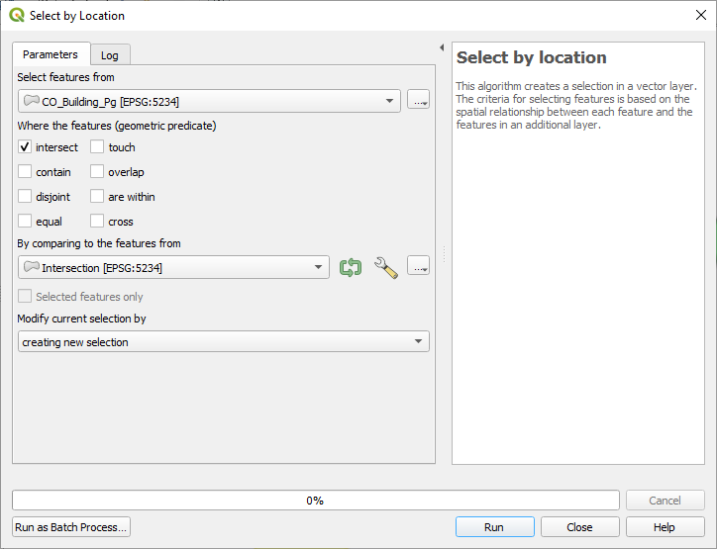

* I then duplicated the isolated features, established a new vector layer, and preserved the dataset.

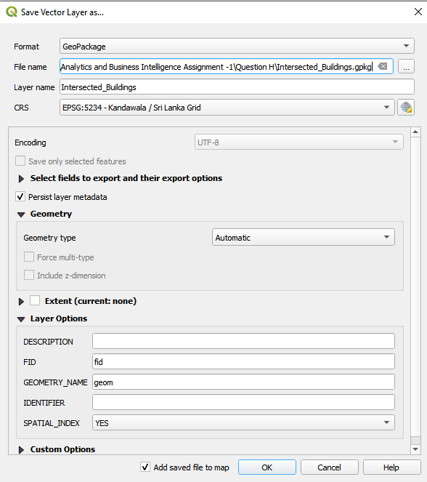

* Below show all installations located just inside the confluence area.

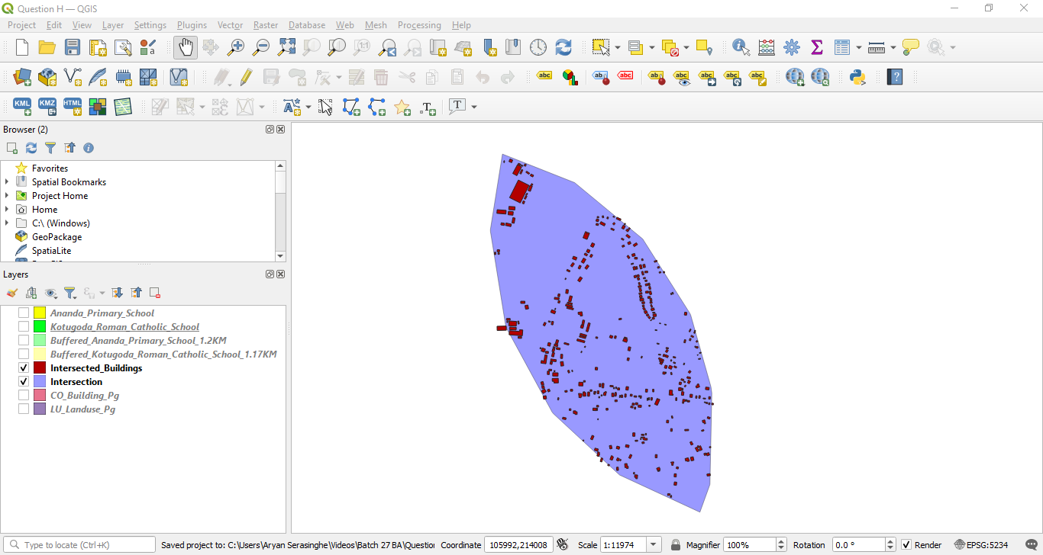

* I then selected land-use topological vector.

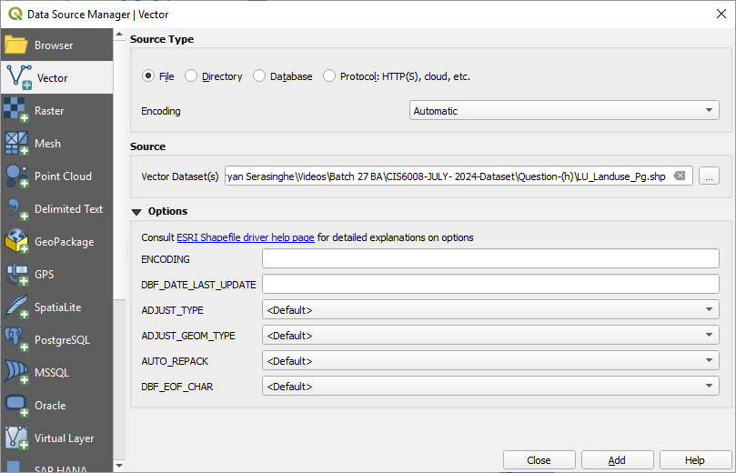

* Within the land-use topological vector, I took the features designated as scrub-land.

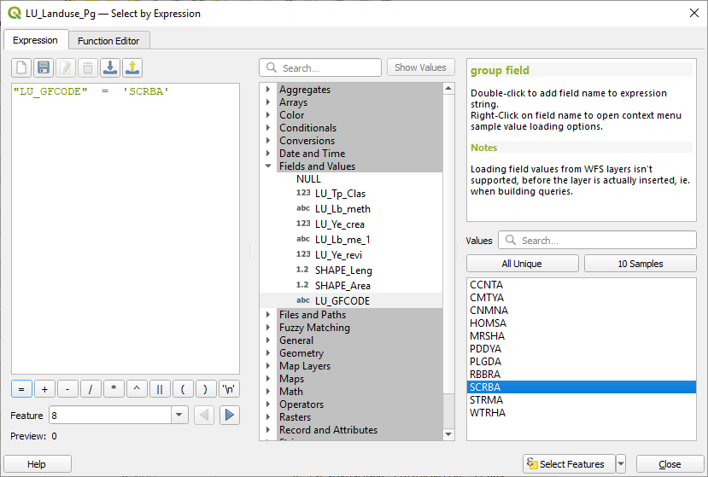

* I have actualized the Task H chart, integrating all conglobated constituents.

